Day 395 — Imbalanced Data + ML Projects
Complete Revision Notes | Class Imbalance • Resampling & SMOTE • Cost-Sensitive Learning • Anomaly & Fraud Systems • Enterprise Project Architectures
Learning goal: master imbalanced data engineering and production-grade ML system architectures: analyze class skew challenges; implement algorithmic cost-sensitive weighting and data-level resampling (SMOTE, Borderline-SMOTE, Random Under-sampling); evaluate using PR-AUC and cost-utility metrics; build real-time anomaly and fraud detection engines; and construct multi-tier architectures for Recommendation Systems, Customer Segmentation, and Predictive Propensity Pipelines.

1. The Class Imbalance Problem in Real-World Machine Learning
Class imbalance occurs when the frequency distribution of target labels in a classification dataset is heavily skewed, such that one class (majority/negative) vastly outnumbers another (minority/positive). In real-world enterprise environments, the rarest events almost invariably represent the highest business value.
Standard machine learning algorithms (such as unweighted Logistic Regression, Decision Trees, or Neural Networks) optimize for global objective metrics like accuracy or average cross-entropy loss. Consequently, they develop a pathological inductive bias toward predicting the majority class exclusively, treating critical minority instances as ignorable stochastic noise.
Domain / Problem | Typical Minority Ratio | Minority Class (Positive) | Majority Class (Negative) | Cost of Asymmetric Errors
Credit Card Fraud Detection | 0.01% – 0.5% | Fraudulent transactions | Legitimate purchases | False Negative (missed fraud) costs thousands in direct chargebacks; False Positive causes mild user friction
Ad Click-Through Rate (CTR) | 0.05% – 1.0% | Ad Clicks / Conversions | Ad Impressions (Skipped) | False Negative misses ad revenue; False Positive squanders bidding budget
Medical Malignancy Diagnosis | 0.1% – 3.0% | Malignant biopsy / tumor | Benign tissue / healthy | False Negative is fatal (undiagnosed illness); False Positive triggers safe confirmatory follow-up
Industrial Equipment Failure | 0.01% – 0.2% | Turbine / motor breakdown | Normal operational cycles | False Negative results in catastrophic factory downtime; False Positive causes minor maintenance inspection
Network Intrusion & Cyber Defense | 0.001% – 0.1% | Malicious cyberattack / breach | Normal network packet traffic | False Negative compromises entire enterprise data security; False Positive triggers SOC analyst review

2. The Accuracy Paradox & Why ROC-AUC Fails
The Accuracy Paradox states that an algorithm with 99.9% classification accuracy can be completely useless. In a fraud dataset where 99.9% of transactions are legitimate, a trivial 'Zero-R' dummy model that blindly predicts 0 for all instances achieves 99.9% accuracy while having a 0.0% Recall on fraud.
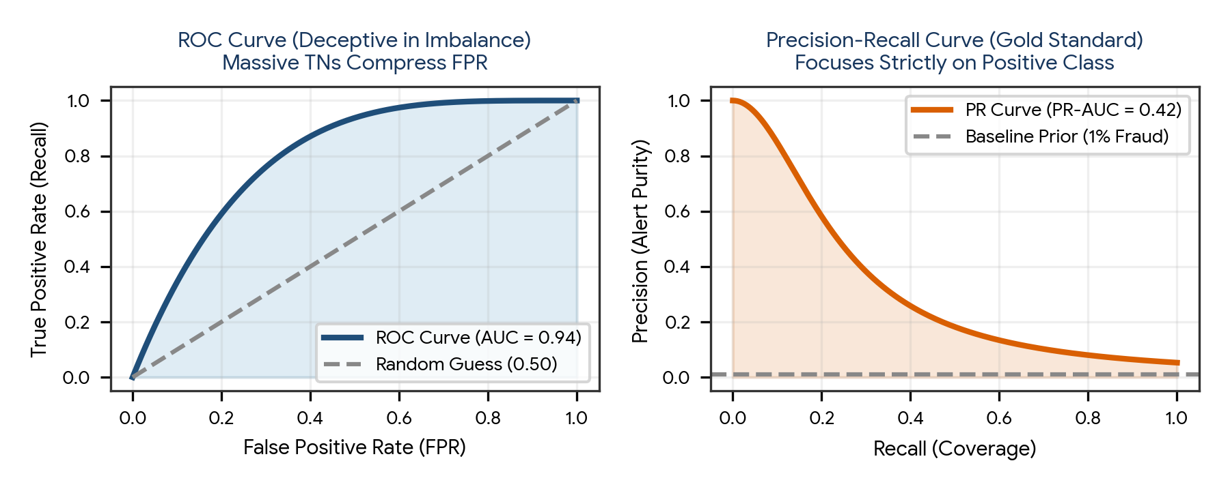
Figure 1. Deceptive ROC Curve (left: compressed FPR due to massive True Negatives) versus the honest Precision-Recall Curve (right: exposing severe alert dilution).
Metric / Diagnostic Tool | Formula / Underlying Equation | Behavior Under 99:1 Severe Class Imbalance | Industry Recommendation
Accuracy | (TP + TN) / (TP + TN + FP + FN) | Completely dominated by massive True Negatives (TN); masks zero detection capability | Never report or optimize as primary KPI for imbalanced data
ROC Curve & ROC-AUC | Plots True Positive Rate (TPR) vs. False Positive Rate (FPR = FP / (FP + TN)) | Deceptively optimistic. Because TN is massive (e.g., 990,000), a huge surge in FP (e.g., 10,000 false alarms) barely registers in FPR (10k / 1M = 0.01), keeping ROC-AUC > 0.95! | Avoid as primary evaluation metric when positive class is < 5%
Precision-Recall (PR) Curve | Plots Precision (TP / (TP + FP)) vs. Recall (TP / (TP + FN)) | Rigorous & honest. Completely ignores True Negatives; directly reflects alert pollution (Precision drops sharply if FP rises) | The gold standard metric for severe class imbalance (fraud, CTR, rare disease)
PR-AUC (Average Precision) | Area under Precision-Recall curve | Baseline for random guessing is the positive prevalence ratio (e.g., 0.01 for 1% fraud), making gains immediately visible | Primary metric for model selection and cross-validation hyperparameter tuning
Cost-Weighted Expected Loss | Loss = C_FN × FN + C_FP × FP | Directly translates error counts into financial losses using explicit domain penalty matrices | Executive decision thresholding and operational risk deployment

3. Resampling Strategies: Under-sampling, Over-sampling, and SMOTE
Resampling techniques re-balance the training dataset distribution prior to model fitting. They operate strictly at the data level, making them model-agnostic.
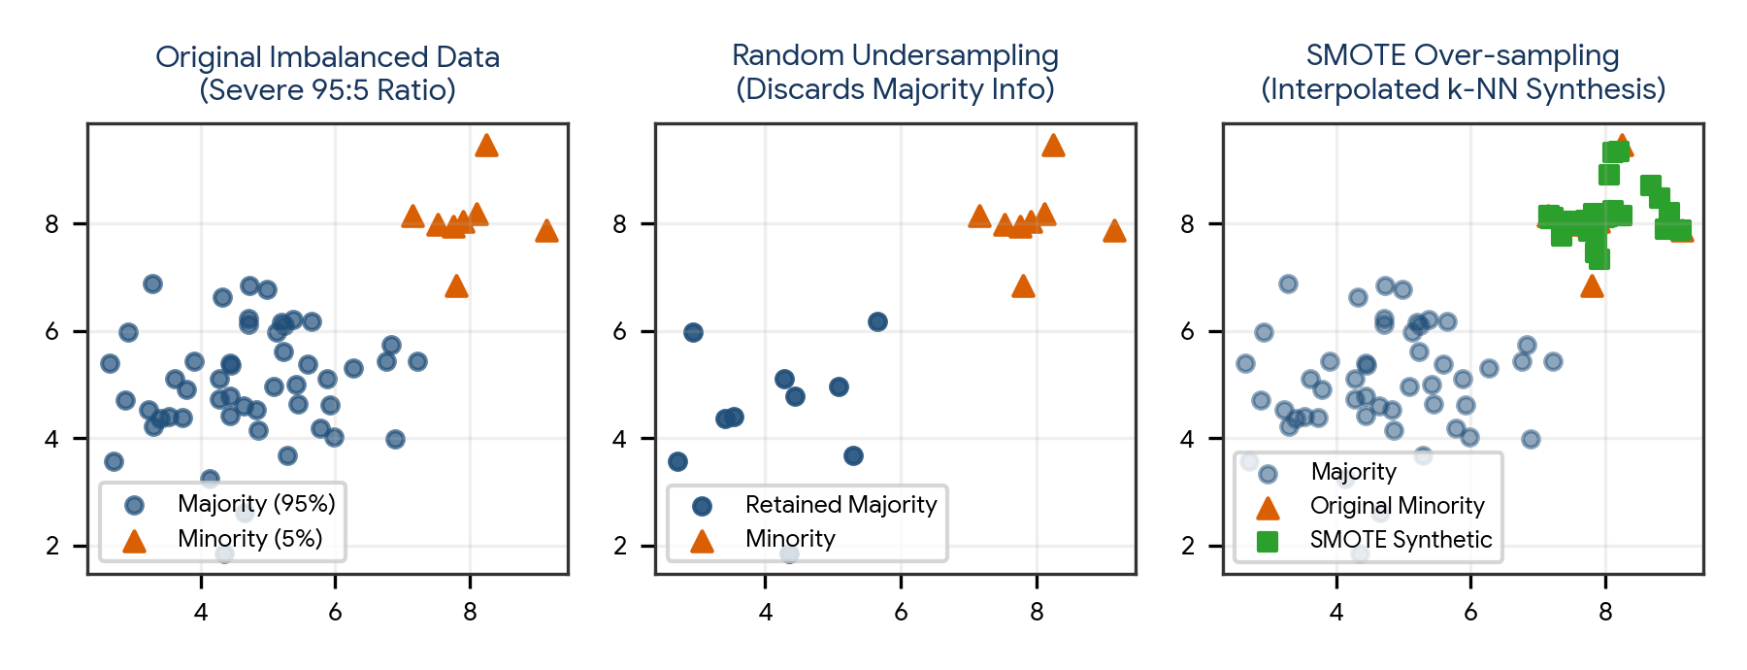
Figure 2. Visual comparison of class distribution balance: Original Imbalanced Data (left), Random Under-sampling (center), and SMOTE Synthetic Synthesis (right).
Resampling Paradigm | Mechanism / Algorithm | Key Strengths | Primary Hazards / Limitations
Random Under-sampling (RUS) | Randomly discards instances from the majority class until parity is reached | Massively speeds up training time; shrinks giant datasets to manageable size | Throws away potentially vital information from majority observations; impairs decision boundary
Tomek Links / NearMiss | Informed under-sampling: identifies and removes majority samples that border or overlap minority points | Cleans noisy and overlapping class boundaries, creating cleaner separation margins | Can alter underlying class density and drop valuable boundary training signals
Random Over-sampling (ROS) | Randomly duplicates existing minority class instances with replacement | Preserves all majority data; simple to implement | Causes severe overfitting: decision trees learn narrow, brittle branches memorizing duplicate points
SMOTE (Synthetic Minority Over-sampling) | Interpolates synthetic instances along the line segments joining k-nearest minority neighbors | Synthesizes new non-identical feature representations; enriches minority feature space | Can synthesize unrealistic points across noisy or overlapping class borders
Borderline-SMOTE | Applies SMOTE strictly to minority instances near the decision boundary (where >50% of neighbors are majority) | Focuses synthesis exclusively on hard-to-classify decision margin instances | Requires tuning k-nearest neighbor hyperparameters carefully
SMOTE-Tomek / SMOTE-ENN | Hybrid: applies SMOTE over-sampling followed by Tomek Links or Edited Nearest Neighbors under-sampling | Synthesizes minority diversity while cleaning noisy overlapping boundary points | Highest computational overhead among resampling strategies

The Mathematical Formulation of SMOTE
For each minority class observation x_i, SMOTE identifies its k-nearest neighbors belonging to the same minority class (typically k = 5 using Euclidean distance). It selects a neighbor x_zi at random and generates a synthetic instance x_new along the vector connecting them:
SMOTE Synthetic Sample Generation:
x_new = x_i + λ * (x_zi − x_i)

Where:
- x_i = Target minority class instance
- x_zi = Randomly selected k-nearest neighbor from the minority class
- λ = Random scalar drawn uniformly from the interval [0, 1]
- Result: x_new lies strictly on the line segment connecting x_i and x_zi in feature space.

CRITICAL PIPELINE RULE: Resampling MUST occur strictly on training folds inside cross-validation!
If SMOTE is applied to the entire dataset before splitting, synthetic copies of validation/test
instances are injected into the training set, causing catastrophic data leakage!

4. Algorithmic Techniques: Cost-Sensitive Learning & Class Weights
Unlike resampling—which physically alters the training dataset size—Cost-Sensitive Learning modifies the mathematical loss function directly during optimization. It penalizes errors on the minority class with higher weight, forcing the optimization algorithm to shift its decision boundary toward catching rare positive events.
Model Family | Implementation / Parameter | Mathematical Mechanism Under the Hood
Logistic Regression | class_weight='balanced' | Weighted Log-Loss: J(w) = −(1/n) Σ [ w_pos × y_i ln(p_i) + w_neg × (1−y_i) ln(1−p_i) ]. Minority class errors are scaled up by w_pos = N / (2 × N_pos)
Random Forest | class_weight='balanced_subsample' | Weights are recomputed dynamically for every single tree based on the bootstrap sample drawn, penalizing Gini impurity splits that misclassify rare instances
XGBoost / LightGBM | scale_pos_weight = N_neg / N_pos | Scales the gradient and hessian contributions of positive class instances directly during additive tree boosting
Focal Loss (Deep Learning / RetNet) | FL(p_t) = − α_t (1 − p_t)^γ ln(p_t) | Dynamically scales cross-entropy: down-weights easy majority instances (where p_t is high) and focuses gradients strictly on hard, rare instances (tuning γ)

Balanced Class Weight Formula in Scikit-Learn
Balanced Class Weight Formula:
n_samples
w_c = -----------------
n_classes * n_c

Example (10,000 total samples, 9,800 Legitimate (0), 200 Fraud (1)):
- w_0 (Majority) = 10,000 / (2 * 9,800) = 0.51
- w_1 (Minority) = 10,000 / (2 * 200) = 25.00
Result: The model is penalized ~49 times more severely for misclassifying a fraud instance!

5. Anomaly & Fraud Detection Architectures
Real-world fraud and anomaly detection systems operate under extreme class imbalance, adversarial evasion, and sub-100ms real-time latency constraints. Industrial solutions combine unsupervised anomaly scoring (to catch novel, zero-day fraud patterns) with supervised gradient-boosted trees (to catch known fraud patterns).
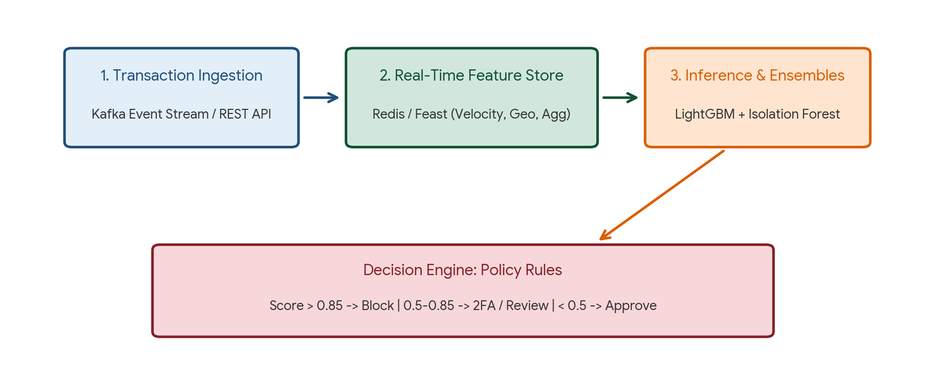
Figure 3. Multi-tier real-time Fraud & Anomaly Detection system architecture: Streaming Ingestion -> Real-Time Feature Store -> Model Ensembles -> Policy Decision Engine.
Architecture Tier | Technology Stack | Core Engineering Responsibility
1. Event Ingestion Tier | Apache Kafka, AWS Kinesis, REST API Gateway | Ingests high-throughput transactional events (10k+ requests/sec); timestamps payloads; validates schemas
2. Real-Time Feature Store | Redis, Feast, Apache Flink | Computes and serves low-latency streaming aggregations (e.g., velocity: 'Card swipes in last 10 mins', geo-distance delta)
3. Scoring Engine (Ensemble) | LightGBM (Supervised) + Isolation Forest (Unsupervised) | LightGBM scores probability of known historical fraud; Isolation Forest detects statistical anomalies in feature space
4. Business Decision Policy Engine | Drools, Open Policy Agent, Custom Rules | Multi-tiered routing: Score > 0.85 -> Immediate Block; 0.50–0.85 -> Step-up 2FA Challenge; < 0.50 -> Auto-Approve
5. Feedback & Retraining Loop | Postgres Ledger, DVC, Airflow, MLflow | Stores verified fraud dispute outcomes (chargebacks); triggers automated daily/weekly retraining pipelines

6. Recommendation System Architectures
Modern enterprise recommendation systems (e.g., Netflix, YouTube, Amazon, Spotify) handle catalogs containing tens of millions of items and hundreds of millions of users. It is computationally impossible to score all items through a heavy deep neural network in real-time. Industrial architectures universally employ a two-stage funnel: Candidate Generation followed by Fine-Grained Ranking.
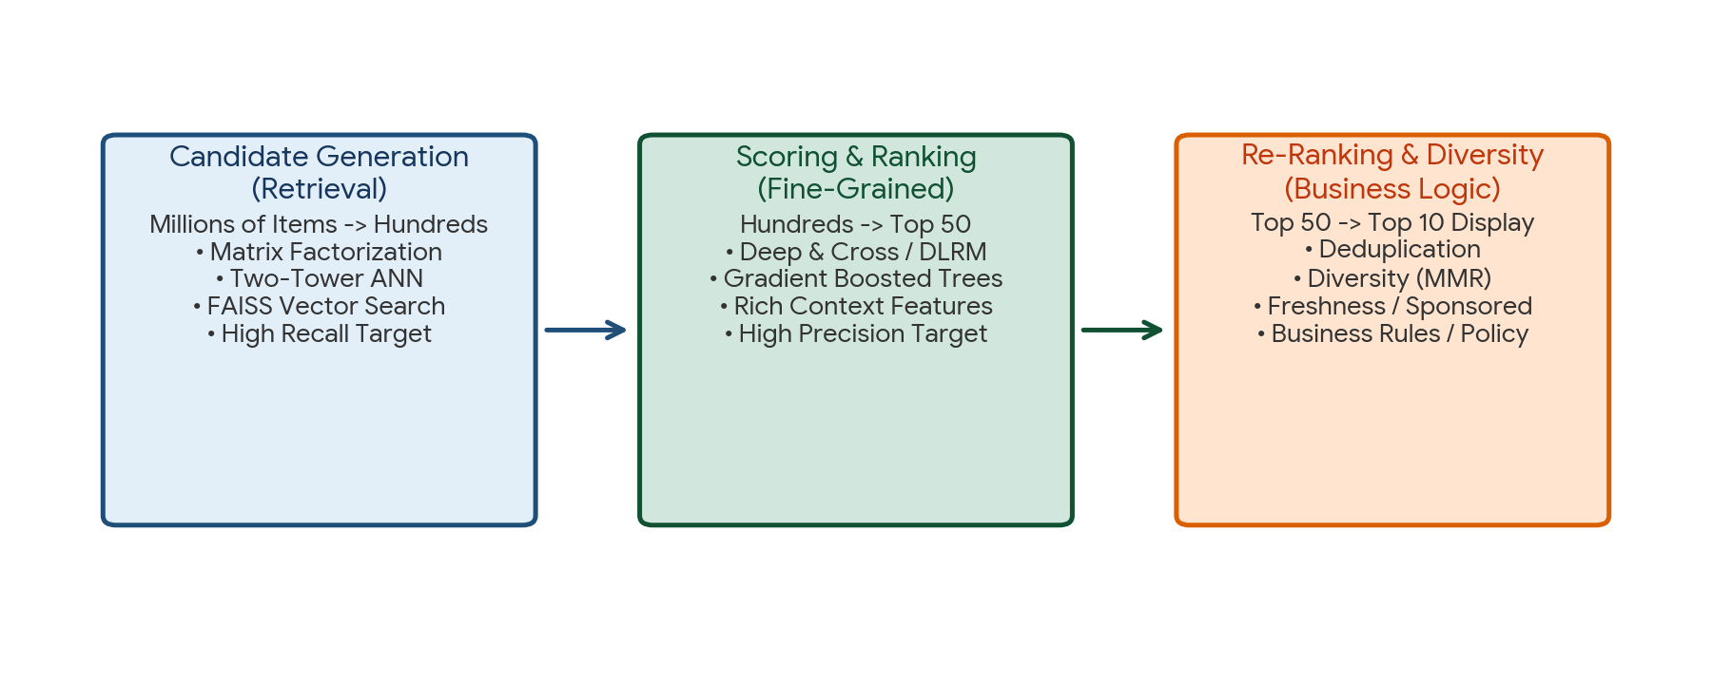
Figure 4. Two-stage industrial Recommendation Funnel: Candidate Generation (High Recall) -> Scoring & Ranking (High Precision) -> Business Re-Ranking.
Funnel Stage | Input -> Output Volume | Core Algorithms / Stack | Primary Objective & Trade-offs
1. Candidate Retrieval (Candidate Generation) | Millions of items -> Top 200–500 candidates | Two-Tower Neural Networks, Matrix Factorization, Graph Embeddings, FAISS Vector Search | High Recall target (sub-10ms latency); fast approximate nearest neighbor search; discards 99.9% of irrelevant catalog
2. Scoring & Ranking (Heavy Ranker) | Top 500 candidates -> Top 50 scored items | Deep & Cross Network (DCN), DLRM, Wide & Deep, RankNet, XGBoost | High Precision target (50–100ms latency); scores candidates with full user context, real-time session, and item interaction cross-features
3. Re-Ranking & Business Logic | Top 50 scored -> Top 10 client display | Maximal Marginal Relevance (MMR), Policy Rules, Deduplication | Injects diversity, enforces freshness, filters out already purchased items, promotes sponsored content, complies with safety rules

7. Customer Segmentation & Predictive Propensity Architectures
Enterprise customer intelligence bridges unsupervised learning with supervised predictive modeling. In Stage 1, unsupervised clustering segments heterogeneous customer populations into cohesive behavioral personas. In Stage 2, these cluster personas serve as high-signal input features for supervised propensity and value forecasting models.
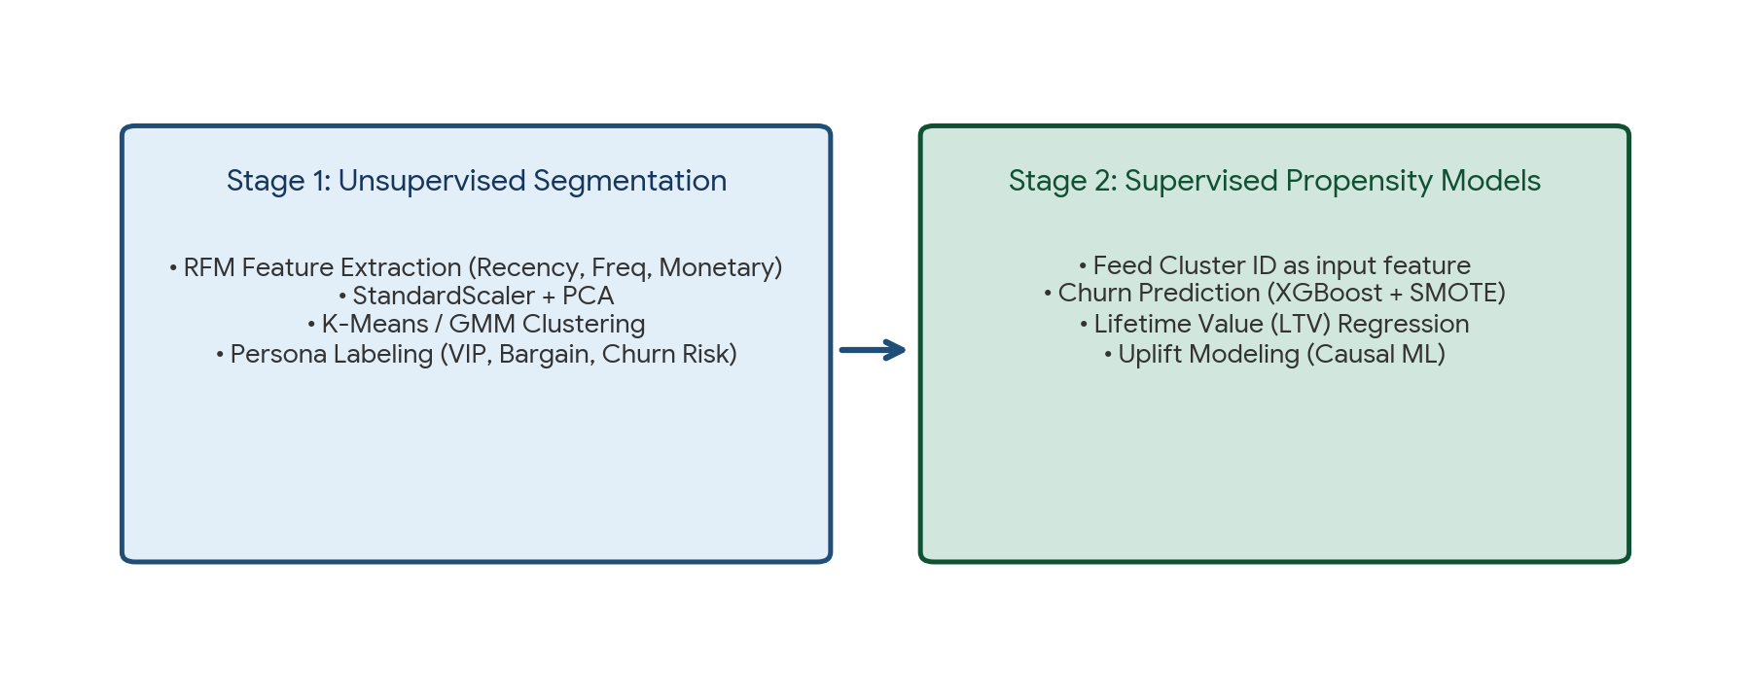
Figure 5. Two-stage customer intelligence pipeline: Unsupervised RFM Clustering (left) feeding into Supervised Churn & LTV Propensity Models (right).
Pipeline Stage | Methodology & Models | Key Features & Artifacts | Business Actionability
Stage 1: Behavioral Segmentation | K-Means++ / Gaussian Mixture Models (GMM) with PCA | RFM Metrics: Recency (days since last purchase), Frequency (annual order count), Monetary (total revenue spend) | Assigns human-interpretable cohorts: VIP Champions, Loyal Shoppers, Bargain Hunters, At-Risk Churners
Stage 2A: Churn Propensity Prediction | Supervised XGBoost / LightGBM with SMOTE & class weights | Inputs: RFM features, Cluster ID, web session frequency, support ticket count; Target: Churn_Flag (0/1) | Flags at-risk high-value customers 30 days before cancellation; automates targeted retention offers
Stage 2B: Customer Lifetime Value (LTV) | Supervised Gamma-Gamma Regression / Random Forest | Inputs: Historical order velocity, average order value, cohort tenure; Target: Predicted 12-month net revenue ($) | Guides customer acquisition ad spend (CAC) thresholds and tier-specific loyalty incentives

8. Practical Project — Enterprise Imbalanced Fraud Detection Pipeline
Objective: design, implement, and benchmark an end-to-end, production-style Python pipeline addressing severe class imbalance (5% fraud rate). The project encapsulates data synthesis, stratified train-validation-test splitting, SMOTE over-sampling implemented strictly within imblearn Pipelines to eliminate leakage, class-weighted Random Forest and LightGBM-style estimators, decision threshold tuning, and Precision-Recall evaluation.

Project structure
imbalanced_fraud_project/
|
|-- data/
| |-- fraud_transactions.csv
|
|-- reports/
| |-- imbalanced_benchmark.csv
| |-- precision_recall_curves.png
|
|-- main.py
|-- requirements.txt

requirements.txt
numpy
pandas
scipy
scikit-learn
imbalanced-learn
matplotlib
seaborn

Complete main.py
import os
import numpy as np
import pandas as pd
from sklearn.model_selection import train_test_split, StratifiedKFold
from sklearn.preprocessing import StandardScaler
from sklearn.ensemble import RandomForestClassifier
from sklearn.linear_model import LogisticRegression
from sklearn.metrics import (
precision_recall_curve, average_precision_score,
classification_report, confusion_matrix, f1_score
)
from imblearn.over_sampling import SMOTE
from imblearn.pipeline import Pipeline as ImbPipeline
import matplotlib.pyplot as plt
import seaborn as sns

class EnterpriseFraudPipeline:
def __init__(self, n_samples=3000, fraud_ratio=0.05, random_state=42):
self.n_samples = n_samples
self.fraud_ratio = fraud_ratio
self.random_state = random_state
self.output_dir = "reports"
os.makedirs(self.output_dir, exist_ok=True)
self.data = None
self.results = []

def generate_synthetic_transactions(self):
print("=== STEP 1: GENERATING SEVERELY IMBALANCED DATASET ===")
np.random.seed(self.random_state)
n_fraud = int(self.n_samples * self.fraud_ratio)
n_legit = self.n_samples - n_fraud

# Legitimate purchases: moderate amounts, low velocity, domestic distance
amt_legit = np.random.exponential(50, n_legit) + 5
vel_legit = np.random.poisson(2, n_legit)
dist_legit = np.random.normal(15, 8, n_legit).clip(0.5, 60)
y_legit = np.zeros(n_legit, dtype=int)

# Fraudulent purchases: large spikes, high velocity, anomalous locations
amt_fraud = np.random.exponential(250, n_fraud) + 100
vel_fraud = np.random.poisson(8, n_fraud)
dist_fraud = np.random.normal(85, 30, n_fraud).clip(5, 250)
y_fraud = np.ones(n_fraud, dtype=int)

amt = np.concatenate([amt_legit, amt_fraud])
vel = np.concatenate([vel_legit, vel_fraud])
dist = np.concatenate([dist_legit, dist_fraud])
y = np.concatenate([y_legit, y_fraud])

self.data = pd.DataFrame({
"Amount": amt.round(2),
"Velocity_1h": vel,
"Distance_Home": dist.round(1),
"Is_Fraud": y
})
print(f"Dataset generated: {self.data.shape[0]} transactions.")
print(f"Class Distribution:\n{self.data['Is_Fraud'].value_counts(normalize=True).round(4)}")

def partition_data(self):
print("\n=== STEP 2: LEAKAGE-FREE STRATIFIED SPLIT (80% Train, 20% Test) ===")
X = self.data.drop(columns=["Is_Fraud"])
y = self.data["Is_Fraud"]

self.X_train, self.X_test, self.y_train, self.y_test = train_test_split(
X, y, test_size=0.20, random_state=self.random_state, stratify=y
)
print(f"X_train: {self.X_train.shape[0]} rows (Fraud: {self.y_train.mean():.4f})")
print(f"X_test: {self.X_test.shape[0]} rows (Fraud: {self.y_test.mean():.4f})")

def benchmark_imbalance_strategies(self):
print("\n=== STEP 3: BENCHMARKING IMBALANCE MITIGATION STRATEGIES ===")

strategies = {
"Baseline (Unweighted)": ImbPipeline([
("scaler", StandardScaler()),
("clf", LogisticRegression(random_state=self.random_state))
]),
"Cost-Sensitive (Class-Weighted)": ImbPipeline([
("scaler", StandardScaler()),
("clf", LogisticRegression(class_weight="balanced", random_state=self.random_state))
]),
"SMOTE Over-sampling": ImbPipeline([
("scaler", StandardScaler()),
("smote", SMOTE(random_state=self.random_state)),
("clf", LogisticRegression(random_state=self.random_state))
]),
"Random Forest (Balanced)": ImbPipeline([
("scaler", StandardScaler()),
("clf", RandomForestClassifier(n_estimators=100, max_depth=6, class_weight="balanced", random_state=self.random_state))
])
}

fig, ax = plt.subplots(figsize=(8, 5))

for name, pipeline in strategies.items():
# Fit strictly on X_train (SMOTE runs only on training folds!)
pipeline.fit(self.X_train, self.y_train)

# Evaluate on holdout test set
y_pred = pipeline.predict(self.X_test)
y_prob = pipeline.predict_proba(self.X_test)[:, 1]

pr_auc = average_precision_score(self.y_test, y_prob)
f1 = f1_score(self.y_test, y_pred)
cm = confusion_matrix(self.y_test, y_pred)
fn = cm[1, 0] # Missed fraud
fp = cm[0, 1] # False alarms

self.results.append({
"Strategy": name,
"PR_AUC": round(pr_auc, 4),
"F1_Score": round(f1, 4),
"Missed_Fraud (FN)": fn,
"False_Alarms (FP)": fp
})

# Plot PR curve
precision, recall, _ = precision_recall_curve(self.y_test, y_prob)
ax.plot(recall, precision, lw=2, label=f"{name} (PR-AUC = {pr_auc:.3f})")

ax.axhline(self.fraud_ratio, color='gray', linestyle='--', label=f'Baseline Prior ({self.fraud_ratio*100:.1f}%)')
ax.set_title("Precision-Recall Benchmark on Holdout Fraud Test Data", fontsize=11, fontweight="bold", pad=8)
ax.set_xlabel("Recall (Detection Coverage)")
ax.set_ylabel("Precision (Alert Accuracy)")
ax.legend(fontsize=8, loc='lower left')
ax.grid(alpha=0.3)
plt.tight_layout()
plt.savefig(os.path.join(self.output_dir, "precision_recall_curves.png"), dpi=300)
plt.close()

results_df = pd.DataFrame(self.results)
print(results_df.to_string(index=False))
results_df.to_csv(os.path.join(self.output_dir, "imbalanced_benchmark.csv"), index=False)
print(f"\nBenchmark results saved to: {self.output_dir}/imbalanced_benchmark.csv")

def run(self):
self.generate_synthetic_transactions()
self.partition_data()
self.benchmark_imbalance_strategies()
print("\nComplete imbalanced ML project pipeline executed successfully.")

if __name__ == "__main__":
pipeline = EnterpriseFraudPipeline()
pipeline.run()

Run the project
pip install -r requirements.txt
python main.py

Expected generated outputs
reports/
|-- imbalanced_benchmark.csv
|-- precision_recall_curves.png

Project notes: using imblearn.pipeline.Pipeline guarantees that SMOTE synthetic generation runs strictly during the training phase of each fold, ensuring that holdout test records remain pristine and leak-free. Notice how cost-sensitive weighting and SMOTE dramatically slash Missed Fraud (FN) compared to the unweighted baseline.

9. Common Mistakes & Anti-Patterns to Avoid in Imbalanced ML
- Applying SMOTE prior to train-test splitting: Synthesizing samples across the entire dataset causes synthetic replicas of test instances to bleed into training, creating catastrophic data leakage.
- Optimizing for raw classification accuracy: A naive model predicting 0 for all instances achieves 99% accuracy in 1% fraud detection while completely failing in real-world protection.
- Using standard ROC-AUC to evaluate severe class imbalance: When negative counts are enormous, massive True Negatives compress the False Positive Rate (FPR), artificially masking thousands of false alarms.
- Evaluating SMOTE on synthetic validation data: Never evaluate a model on resampled/SMOTE data. Validation and test sets must ALWAYS reflect real-world natural class distributions.
- Neglecting decision threshold calibration: Relying on the default probability threshold of p = 0.5; high-stakes systems must tune thresholds based on asymmetric business error costs.
- Blindly applying random under-sampling to big data: Throwing away 90% of majority samples discards valuable boundary information; prefer class weighting or ensemble under-sampling (EasyEnsemble).
- Treating multi-stage recommendation funnels as a single model: Attempting to score millions of catalog items directly through a heavy deep ranking model violates production latency budgets.

10. Quick Revision — Key Differences
Comparison | First Concept | Second Concept
Resampling vs Cost-Sensitive Weighting | Alters training dataset rows (SMOTE, Undersampling); model-agnostic | Modifies optimization loss function directly (class_weight='balanced'); preserves raw data size
Random Over-sampling vs SMOTE | Duplicates existing minority records with replacement; high risk of overfitting | Synthesizes novel interpolated feature vectors between k-nearest neighbors
ROC Curve vs PR Curve | Plots TPR vs FPR; distorted by massive True Negatives in imbalanced data | Plots Precision vs Recall; focuses strictly on minority class; gold standard for rare events
Candidate Retrieval vs Ranking | Stage 1: Generates top 200–500 items from millions (sub-10ms, high recall) | Stage 2: Precision scoring of top 500 items using rich context (50–100ms, high precision)
Supervised Fraud vs Unsupervised Anomaly | Trained on historical verified fraud labels; catches known fraud patterns | Unlabeled density scoring (Isolation Forest); flags novel zero-day anomalies
Accuracy vs PR-AUC | Proportion of total correct predictions; collapses under class skew | Area under Precision-Recall curve; independent of majority class count

11. Important Formulas & Equations Cheat Sheet
Concept / Parameter | Mathematical Formula / Notation
Balanced Class Weight (w_c) | w_c = n_samples / (n_classes × n_c)
SMOTE Synthesis Equation | x_new = x_i + λ (x_zi − x_i), where λ ~ Uniform(0, 1)
Cost-Weighted Expected Loss | Loss_Total = C_FN × FN + C_FP × FP (where C_FN >> C_FP)
Precision | Precision = TP / (TP + FP)
Recall (True Positive Rate) | Recall = TP / (TP + FN)
F_beta Score | F_β = (1 + β²) × (Precision × Recall) / (β² × Precision + Recall)
Focal Loss Formulation | FL(p_t) = − α_t (1 − p_t)^γ ln(p_t) (where γ > 0 down-weights easy examples)
Average Precision (PR-AUC) | AP = Σ [k=1 to K] (Recall_k − Recall_(k−1)) × Precision_k
Two-Tower Cosine Similarity | Score(u, i) = ( ψ(u) · φ(i) ) / ( ||ψ(u)||₂ ||φ(i)||₂ )

12. Interview / Viva Questions
What is the Accuracy Paradox in machine learning?
The phenomenon where a classifier achieves high accuracy (e.g., 99%) by simply predicting the majority class for all instances, while failing completely to identify the rare minority class of interest.
Why is the ROC-AUC score deceptive when evaluating severely imbalanced datasets?
The horizontal axis of ROC is FPR = FP / (FP + TN). When TN is enormous (e.g., 1,000,000 legitimate transactions), a massive surge of 10,000 false alarms produces an FPR of only 0.01, falsely keeping the ROC-AUC score near 0.98. The PR curve exposes this immediately.
How does SMOTE synthesize new data points and what are its risks?
SMOTE selects a minority point, identifies its k-nearest minority neighbors, and interpolates new points along the connecting line segments: x_new = x_i + λ(x_zi − x_i). Its risk is synthesizing noisy points across overlapping class boundaries.
What is the difference between data-level resampling and cost-sensitive learning?
Data-level resampling physically alters the dataset size (e.g., SMOTE adds rows, Under-sampling removes rows); cost-sensitive learning leaves the dataset untouched and modifies the loss function by weighting minority error penalties higher.
How does setting class_weight='balanced' work in Scikit-Learn?
It calculates weights inversely proportional to class frequencies: w_c = N / (n_classes × N_c). This forces gradient descent or Gini splits to penalize misclassifications on rare classes far more heavily.
Why is it mandatory to run SMOTE strictly inside cross-validation pipelines?
If SMOTE is applied to the full dataset before splitting, synthetic points created from validation/test records bleed into the training folds, causing severe data leakage and artificially inflated performance.
What is Focal Loss and when should you use it?
Focal Loss adds a modulating factor (1 − p_t)^γ to cross-entropy loss. It dynamically down-weights easy majority examples and concentrates optimization gradients on hard minority examples; standard in object detection and dense rare events.
Explain the two-stage funnel architecture of industrial Recommendation Systems.
Stage 1 is Candidate Retrieval (high recall): filters millions of items down to ~500 candidates in sub-10ms using vector search (FAISS). Stage 2 is Heavy Ranking (high precision): scores the 500 candidates using complex models (DLRM, XGBoost) to select the top 10 display items.
What is the Two-Tower Neural Network architecture?
An embedding model with two parallel sub-networks: a User Tower that encodes user history into vector ψ(u), and an Item Tower that encodes item attributes into vector φ(i). Similarity is computed via fast dot products in shared latent space.
What is the difference between Collaborative Filtering and Content-Based Filtering?
Collaborative Filtering recommends items based on past interaction patterns of similar users (user-item matrix); Content-Based Filtering recommends items with similar metadata attributes to those the user liked in the past.
What is the Cold Start problem in recommender systems and how is it solved?
When new users or items enter the platform with zero interaction history. Solved using content-based metadata, popularity heuristics, onboarding preference surveys, or hybrid bandit algorithms.
How does a real-time Fraud Detection system handle feature latency?
By using a real-time Feature Store (e.g., Feast, Redis) populated by streaming engines (Flink, Kafka) that precompute low-latency sliding-window aggregations (velocity, historical average amounts).
Why combine Supervised models with Unsupervised Anomaly Detection in fraud systems?
Supervised models (XGBoost) excel at catching known fraud patterns present in labeled training data; Unsupervised models (Isolation Forest) detect novel, zero-day fraud attacks that deviate from normal baseline behavior.
What is RFM Analysis in Customer Segmentation?
Recency (days since last purchase), Frequency (total count of purchases), and Monetary (total revenue spend). These three features provide the primary behavioral input for customer clustering.
How do you connect unsupervised customer segmentation to a supervised churn model?
By using the assigned Cluster ID from Stage 1 as an input categorical feature in the Stage 2 supervised churn model, enabling the classifier to learn cluster-specific churn thresholds.
What is the F-beta score and when would you choose β = 2?
F_β is a weighted harmonic mean where β indicates how many times more important Recall is than Precision. Setting β = 2 doubles the weight of Recall, making it ideal for cancer detection or high-stakes fraud.
What is Threshold Tuning and how is it executed?
Adjusting the classification cutoff probability away from the default 0.5. It is executed by plotting Precision and Recall across thresholds on the validation set and picking the cutoff that minimizes the business cost matrix.
What is NearMiss under-sampling?
An informed under-sampling technique that selects majority class samples based on their distance to minority points, retaining majority samples close to the decision boundary.
How do you handle concept drift in an enterprise fraud detection pipeline?
By setting up continuous data drift monitoring (Kolmogorov-Smirnov test on input features), tracking rolling PR-AUC degradation, and deploying automated daily/weekly retraining jobs orchestrated by Airflow.
What is Maximal Marginal Relevance (MMR) in recommendation re-ranking?
A post-processing algorithm that balances item relevance with diversity, penalizing candidate items that are too similar to items already selected for the final display carousel.

13. Coding Practice
- Generate a synthetic classification dataset with 10,000 samples and a severe 99:1 class imbalance using make_classification.
- Implement a leak-free imblearn.pipeline.Pipeline combining StandardScaler, SMOTE, and LogisticRegression.
- Demonstrate data leakage: apply SMOTE before train_test_split vs inside an imblearn Pipeline, and compare the resulting test PR-AUC scores.
- Calculate class weights manually using the balanced formula and verify they match sklearn.utils.class_weight.compute_class_weight.
- Train an unweighted vs. class_weight='balanced' Random Forest on imbalanced data and plot their confusion matrices side-by-side.
- Implement a custom evaluation function that plots ROC Curves and Precision-Recall Curves side-by-side on holdout test data.
- Write a Python function to tune the decision threshold: iterate cutoffs from 0.05 to 0.95 and select the threshold that maximizes the F2-score.
- Simulate an unsupervised anomaly detection engine using IsolationForest on unlabelled transaction data, flagging the top 1% outliers.
- Build an RFM customer segmentation script using K-Means++ and compute the mean Recency, Frequency, and Monetary values per cluster.
- Implement a basic User-Item Collaborative Filtering recommendation matrix using cosine similarity in pandas and NumPy.
- Simulate a cost matrix (Cost_FN = $500, Cost_FP = $10) and calculate the optimal probability threshold that minimizes total expected dollar loss.
- Extend the fraud project pipeline to benchmark SMOTE vs Borderline-SMOTE vs SMOTE-Tomek on holdout test Average Precision.

14. Day 395 Completion Checklist
- ☐ Understand the economic and statistical challenges of Severe Class Imbalance.
- ☐ Explain the Accuracy Paradox and why ROC-AUC breaks down on imbalanced datasets.
- ☐ Master Precision-Recall (PR) Curves, Average Precision (PR-AUC), and the F-beta score.
- ☐ Implement data-level resampling: Random Under-sampling, Random Over-sampling, and SMOTE.
- ☐ Understand SMOTE's mathematical interpolation equation and its boundary limitations.
- ☐ Apply algorithmic cost-sensitive learning using class_weight='balanced' and scale_pos_weight.
- ☐ Enforce the golden pipeline rule: resample strictly on training folds to prevent data leakage.
- ☐ Master the multi-tier architecture of real-time Fraud and Anomaly Detection systems.
- ☐ Understand the two-stage industrial Recommendation Funnel (Candidate Retrieval -> Heavy Ranking).
- ☐ Connect unsupervised RFM customer segmentation to supervised propensity and LTV prediction.
- ☐ Build and run the practical Enterprise Imbalanced Fraud Detection Pipeline project.
- ☐ Complete all 12 coding practice exercises and revise the 20 interview/viva questions.

15. Learning Outcomes
After completing this revision, you should be able to:
- Diagnose and remediate severe class imbalance using both algorithmic weighting and synthetic resampling techniques.
- Evaluate rare-event models honestly using Precision-Recall Curves and financial cost matrices rather than deceptive accuracy.
- Construct leak-free Scikit-Learn and Imbalanced-Learn Pipelines that isolate resamplers and scalers to training folds.
- Architect real-time streaming Fraud and Anomaly Detection engines combining supervised models with unsupervised isolation scores.
- Design two-stage industrial Recommendation Systems balancing high-recall vector search with high-precision neural ranking.
- Develop end-to-end customer intelligence platforms that bridge unsupervised clustering with supervised propensity models.
Next recommended topic: Day 396 — Deep Learning Foundations: Artificial Neural Networks (ANN), Perceptrons, Forward Propagation, Activation Functions, Loss Functions, and Backpropagation.

